Save Families From COVID-19

The Coronavirus pandemic has caused devastation across the globe. Besides the tragic toll on

human life, with countries shutting their borders and quarantines, economies have taken a huge hit.

The tragedy has just begun to unfold in India and the job losses are mounting, especially among the

daily wage workers. Experts say the effect on this group will be catastrophic.

Coronavirus is an international disaster on the scale of the Second World War. We have launched

this campaign as an emergency response - to help provide a safety net to casual labour families.

We aim to directly support these families by providing a minimum wage in cash, hopefully with

your support till the virus abates and they are in employment again.

These unemployed individuals have been duly verified by GiveIndia. The whole world is suffering -

and is trying to cope with huge losses. But those without any job security or savings are the most

vulnerable. Give generously to those hardest hit by COVID-19. 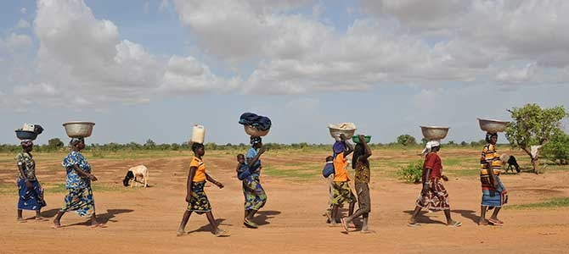

## ₹Support Humanity & Inclusion—a 38-year-old international charity

COVID-19 affects the people we assist every day—people with disabilities or chronic health conditions, people with injuries, refugees, and especially older people.

Many of our 2.1 million beneficiaries live in poverty. They regularly experience exclusion. We are particularly concerned for refugees and displaced people. Often living in for

**GiveIndia charges 0% for all COVID-19 fundraisers, 100% of your donation is forwarded towards relief efforts.**

Partnering with the

most credible

nonprofits to prevent

the spread of

Coronavirus all world



How you can help

You can be a part of the solution to provide a safety-net for the thousands of poor labourers who have lost their jobs due to Coronavirus

### ₹ 7,000

Helps 1 family in a tier 1 city for a month

### ₹ 5,000

Helps 1 family in a tier 2 city for a month

Impact

Cash in their hands helps to

Pay basic essentials

Buy basic rations to feed their families

Survive sudden loss of income due

-

₹Top of FormBottom of Form

### Calling sing Helpline

Komen’s breast care and clinical trial information helpline.

### Treatment Assistance

Helping patients stay in treatment through assistance programs.

### Patient Support

Guiding patients through difficult decisions and providing social and emotional support.

### Advocacy Efforts

Advocating for breast cancer patients, research, and needs among policy makers.

### Research Funding

Funding for lifesaving research and clinical trials.

**DONATE NOW**